**2023**

**Year 12 Earth and Environmental Science – Unit 3**

**Task 7: Fossils and Fossil Fuels Test**

**Weighting: 9%**

**Name: __________________________**

**Date: ___________________**

|  |  |
| --- | --- |
| **Total Mark** |  |

*I acknowledge that all the information contained in this task is my own work and not taken from other sources. If other sources have been used they have been acknowledged in my references.*

____________________________________

(Student Signature)

*Please see SEQTA for teacher feedback and comments.*

1. Fill in the blanks in the flow chart for oil and gas formation using the provided word bank. (7 marks)

|  |  |  |  |  |
| --- | --- | --- | --- | --- |
| Three to six | Heat | Sea floor | Pressure | Sedimentary |
| Impermeable rock | Metamorphic | Buried | Igneous | Ocean |

Organic matter settles onto the ________________________

It is then ________________________ to a depth of about ______________ km.

It is subjected to __________________ and _____________________.

It migrates through _____________________________ rock until it is trapped by

_________________________.

1. Describe the differences between fossils and fossil fuels. (2 marks)

____________________________________________________________________________________________________________________________________________________________________________________________________________________________________________________________________________________________________________

1. While exploring a new beach site, geologists identified a layer of fossilised shells in a limestone cliff formation. At the time when the shell layer was forming, there would have been many other animals living in the area, including marine organisms with soft bodies. Outline why only the fossils found in the rock face were from shellfish. (2 marks)

________________________________________________________________________________________________________________________________________________________________________________________________________________________________________________________________________________________________________________

1. List three different types of fossils. (3 marks)

|  |  |  |  |  |
| --- | --- | --- | --- | --- |
|  |  |  |  |  |

1. Oil and natural gas, and coal are both considered fossils fuels however they are formed differently. List two differences and two similarities in the formation of them. (4 marks)

|  |  |
| --- | --- |
| Similarities | Differences |
|  |  |
|  |  |

1. Explain why fossil fuels are considered non-renewable resources. (2 marks)

____________________________________________________________________________________________________________________________________________________________________________________________________________________________________________________________________________________________________________

1. Identify two negative impacts of using fossil fuels. (2 marks)

____________________________________________________________________________________________________________________________________________________________________________________________________________________________________________________________________________________________________________

1. What are two environmental conditions required for fossilisation to occur. (2 marks)

____________________________________________________________________________________________________________________________________________________________________________________________________________________________________________________________________________________________________________

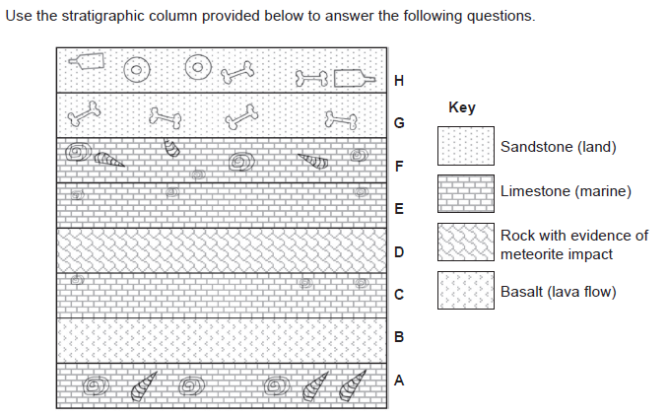

1. A scientist concludes that Layer E has fewer fossils because of the impact of a meteorite. Give one reason why a meteorite impact is linked to species loss. (2 marks)

______________________________________________________________________________________________________________________________________________________

1. There is a marine layer at F and a terrestrial (land) layer at G. identify and explain an Earth process that could account for this change. (2 marks)

____________________________________________________________________________________________________________________________________________________________________________________________________________________________________________________________________________________________________________

Oil and gas were ‘made’ over millions of years form plants and animals. A group of Earth and Environmental Science students decided to investigate if the amount of plankton buried under sediment impacted the amount of oil and gas that might form. As they do not have millions of years to conduct this research, they work with biogas instead. As biogas forms from rotting plant and animal material in a matter of days.

1. Identify the following variables for this investigation. (4 marks)

Independent variable: ___________________________________________

Dependent variable: ____________________________________________

Two controlled variables: ______________________________________________________ ___________________________________________________________________________

1. Write a hypothesis for this investigation. (2 marks)

_________________________________________________________________________________________________________________________________________________________________________________________________________________________________

Upon completing the investigation, the students came up with the below results.

|  |  |
| --- | --- |
| Plankton Amount (grams) | Biogas Produced (cubic meters) |
| 50 | 0.75 |
| 100 | 1.23 |
| 150 | 1.85 |
| 200 | 2.41 |
| 250 | 2.95 |
| 300 | 3.57 |
| 350 | 4.14 |

1. Use the below space to create a graph based on the student data. (4 marks)



1. Referring to the data, explain the relationship between the amount of plankton buried and the amount of biogas produced. (2 marks)

____________________________________________________________________________________________________________________________________________________________________________________________________________________________________________________________________________________________________________

**END OF ASSESSMENT**